**VELAMMAL BODHI CAMPUS**

**PART TEST - 2**

#### STD : X Time Allowed: 3 Hrs

**SUB : ENGLISH MARKS : 80**

**General Instructions:**

1. 15-minute prior reading time allotted for Q-paper reading.
2. The Question Paper contains THREE sections READING, GRAMMAR & WRITING and LITERATURE.
3. Attempt question based on specific instructions for each part.

**SECTION A- READING SKILLS 20**

#### Read the passage given below. 10

* 1. The choices we make on a daily basis—wearing a seat belt, lifting heavy objects correctly Or purposely staying out of any dangerous situation—can either ensure our safety or bring about potentially harmful circumstances.
  2. You and I need to make a decision that we are going to get our lives in order. Exercising

self-control, self-discipline and establishing boundaries and borders in our lives are some of the most .

important things we can do. A life without discipline is one that’s filled with carelessness.

* 1. We can think it’s kind of exciting to live life on the Edge. We like the image of “Yeah! That’s me!

Living On the edge! Woo-hoo!” It’s become a popular way to look at life. But if you see, even highways have lines, which provide margins for our safety while We’re driving. If we go over one side, we’ll go into the ditch. If we cross over the line in the middle, we could get killed. And we like those lines because they help to keep us safe. Sometimes we don’t even realize how lines help to keep us safe.

* 1. I’m not proud of this, but for the first 20 years of my life at work, I ignored my limits. I felt horrible, Physically, most of the time. I used to tell myself “I know I have limits and that I’ve reached them, but I’m going to ignore them and see if or how long I can get by with it.” I ran to doctors, trying to make myself feel better through pills, vitamins, natural stuff and anything I could get my hands on. Some of the doctors would tell me, “It’s just stress.” that just made me mad. I thought stress meant you don’t like what you do or can’t handle life, And I love what I do. But I kept pushing myself, Travelling, doing speaking engagements and so On— simply exhausting myself.
  2. Finally, I understood I was living an unsustainable life and needed to make some changes in my outlook and lifestyle. You and I don’t have to be like everyone else or keep up with anyone else. Each of us needs to be exactly the way we are, and we don’t have to apologize for it. We’re not all alike and we need to find a comfort zone in which we can enjoy our lives instead of making ourselves sick with an overload of stress and pressure.

**On the basis of your understanding of the above passage, answer the questions that follow:**

i. Why has living on the edge become popular? 2

ii. Choose the option that best captures the central idea of the passage from the given quotes.

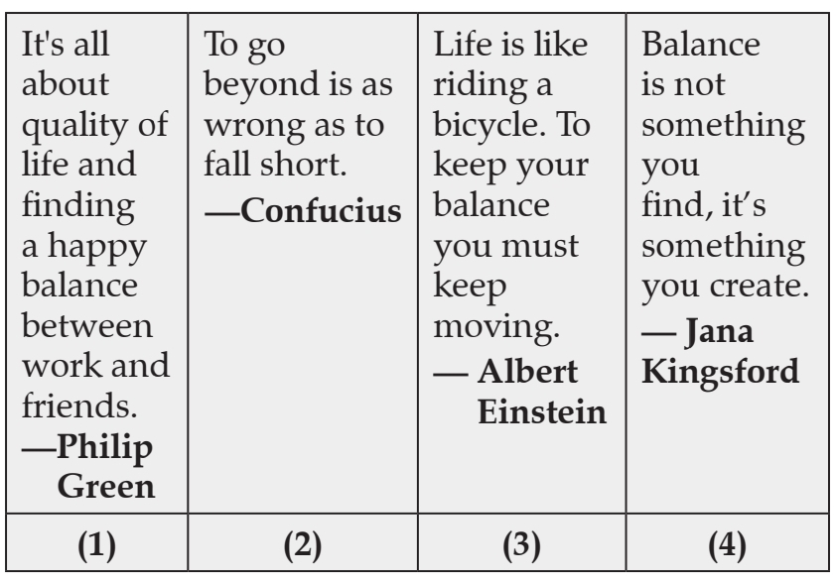

1. Option (1) (B) Option (2) (C) Option (3) (D) Option (4)

iii. What does the author mean when he says, “to get Our lives in order”?

1. To resume our lives. (B) To organize our lives. (C) To rebuild our lives. (D) To control our lives.

iv. Which of the following will be the most appropriate title for the passage?

1. Much too soon. (B) Enough is enough (C) How much is too much? (D) Have enough to do?

v. What does the phrase “potentially harmful circumstances” refers to?

1. Dangerous in times to come. (B) Be fairly dangerous.

(C) be possibly dangerous. (D) Seldom be dangerous.

vi. Select the option that makes the correct use of “unsustainable”, as used in the passage, to fill in

the blank space.

1. In the long run, the ______ officials followed emergency procedures.
2. Emergency procedures were _______ by the Officials.

( C) Officials reported an ________ set of events during the emergency.

( D) Officials admit that the emergency system is ______ in the longer run.

vii. What is the central idea of the passage? 2

viii. The author uses colloquial words such as “yeah” and “Woo-hoo!”. Which of the following is NOT a colloquial

word?

1. Hooked. (B) guy. (C) stuff (D) stress

#### Read the passage given below. 10

* 1. The Nobel Prize is an international award administered by the Nobel Foundation and is based on the fortune of

Alfred Nobel, a Swedish inventor and entrepreneur. The Nobel prize is awarded for the best contribution in the

Fields of Physics, Chemistry, Medicine, Literature and to the person who has contributed by and large to bring

Peace on Earth. In 1968, Sweden’s central bank established the Sveriges Riksbank’s Prize in Economic Sciences

in memory of Alfred Nobel.

* 1. A look into the history of the recipients of the award reveals that only 57 women have received the award

compared to 873 male recipients. There are various historical reasons for why this is the case, but the trend

appears to be improving.

* 1. Goran Hansson, the permanent secretary of the Royal Swedish Academy of Sciences said, “While more women

are being recognised now compared with previous decades, only about 10% of the professors in natural sciences

in western Europe or North America are women, and even lower if you go to east Asia.” All over the world, the

Number of men working in STEM fields is much higher than the number of women.

* 1. Hansson emphasised that they have made sure to identify the problem and also learn about subconscious

Bias in the prize-awarding committees and academies. “We’ve had lectures by sociologists, we’ve had group

Discussions, we have put quite a lot of effort into it,” he said.

* 1. 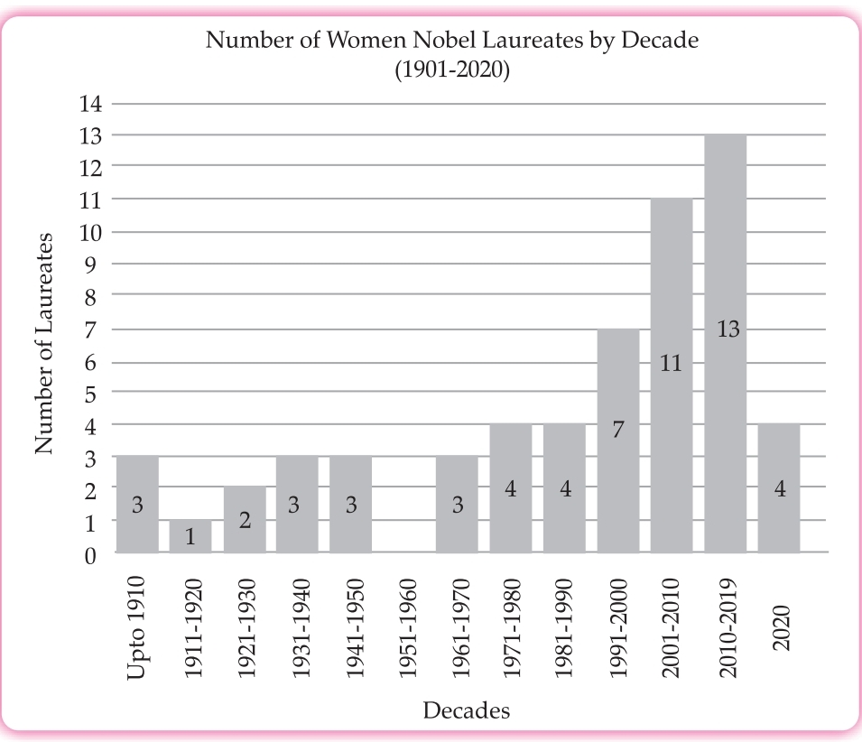“In the end, we will give the prize to those who are found the most worthy, those who have made the most important contributions,” he added.

### **Based on your understanding of the passage, answer the questions given below.**

i) According to the passage, what is the reason for the gender disparity among the Nobel Prize recipients? 2

ii) Based on the passage, what efforts are being made by the Royal Swedish Academy of Sciences to address the

low representation of female Scientists?

iii) According to Goran Hansson, the Royal Swedish Academy of Sciences __________.

1. Researches the cause of gender discrepancy in Nobel prize nominations
2. Nominates fewer men for prestigious awards like the Nobel prize
3. awards the Nobel prize to the most famous contributors
4. Selects individuals who are not prejudiced in any way

iv) Which of these pieces of information is NOT Present in the passage?

1. Number of Nobel prizes given in the year 2009
2. Number of men who have received Nobel Prizes till date
3. percentage of male scientists belonging to Eastern countries
4. Percentage of female scientists belonging to Western countries

v) Select the sentence that CORRECTLY uses the Phrase ‘by and large’ as used in paragraph I.

1. Paula prepared a by and large cake for dinner.
2. We bought by and large clothes for the Campaign.
3. Most of the lions by and large eat deer when hungry.
4. She was so excited that she screamed by and large on the road.

vi) What can be inferred from the graph showing the number of women Nobel laureates by decade? 2

vii) Identify the opinion from these statements about the information shared in the passage.

1. The Nobel prizes have been awarded to more men than women.
2. Alfred Nobel’s wealth is used to award the Nobel prizes to the winners.

(C) The Nobel prize was awarded for the best contribution in only four fields initially.

(D) Women in general are more inclined to working on world peace than on other subjects.

viii) The maximum number of Women Nobel Laureates was recorded in_________________.

1. 1991 -2000. (B) 2001-2010. (C) 2010-2019. (D) 2020

**SECTION B- GRAMMAR 10**

#### Attempt ANY TEN of the following questions.

i. Fill in the blank by using the correct option, for the given portion of a letter:

Dear Sir

This is with reference to committee’s letter of recommendation that highlights the

nominations for ‘Safe Residential Area’ award for ______ current year.

A.That B. the. C. this. D. A

ii. Read the given sentence from a recipe review article. Choose the correct option to fill in the blanks.

This delightful recipe will keep your hunger pangs at bay with _____ balanced spices and

Oriental flavor.

* + 1. It’s B. Its C. A. D. An

iii. Abhilash and Neha had a conversation about the inauguration of Neha’s Dance Academy.

Report Abhilash’s question.

Is your best friend helping you in this venture?

iv. Read the dialogue between Shabnam and her mentor, Sara, regarding her summer internship

programme.

Sara: Why did you choose to participate in this internship programme?

Shabnam: Ah! I am convinced this programme has the potential to enhance my abilities.

Select the correct option to complete the reporting of the above dialogue.

Sara asked Shabnam _________________________________ in that internship programme.

Shabnam sighed and exclaimed that she was convinced that programme had the potential to

Enhance her abilities.

A. Why to choose to participate. B.To choose participation

* 1. Why he had chosen to participate. D. with her choice in participating

v. Fill the blank by choosing the correct option, to complete the concluding line of an issued

circular by an Organization, to its Managers.

A copy of the plan is enclosed and __________ (that/ then/ this) may be communicated to all

Team Leaders for compliance.

vi. Identify the error and supply correction for the given sentence from a commercial company’s

current marketing strategy.

A company aims at increasing authority in areas frequently visited by the clients.

Use the given format for your response.

|  |  |
| --- | --- |
| Error | Correction |
|  |  |

vii. A sentence has been given in Direct Speech. Out of the four altenatives suggested select the one

which best expresses the same sentence in Indirect Speech.

The monk said to the followers “Anger kills Intellect”

* 1. The monk said to the followers anger kills intellect
  2. The monk told the followers that anger kills intellect
  3. The monk asked followers if anger kills intellect
  4. The monk told the followers that anger has killed intellect

viii. Complete the given narrative, by filling the blank with the correct option.

The experience of nursing an injured bird left me feeling grateful for knowing the

importance of being kind and compassionate to _____ creatures.

A. The B. all C. a. D. Both

ix. Report the dialogue between a vendor and his customer, by completing the sentence:

Vendor: It is nice to see you, Sir!

Customer: Yes, indeed! Unlike last month, I have been away for quite some time this month.

The vendor greeted his customer respectfully and mentioned that he was pleased to see him.

The customer answered in the affirmative and explained that __________.

x. The officer said to the clerk, “File these papers immediately.

A.The officer said to the clerk to file these papers immediately.

B.The officer ordered to the clerk to file those papers immediately.

C.**The officer ordered the clerk to file those papers immediately.**

**D. None**

xi. Identify the error and supply the correction in the given format

Varathan told Valli that their family had plan for a picnic.

|  |  |
| --- | --- |
| Error | Correction |
|  |  |

xii. Identify the error and supply correction in the given format.

Ram said that he is preparing for the next day’s test.

|  |  |
| --- | --- |
| Error | Correction |
|  |  |

**SECTION B- CREATIVE WRITING SKILLS 10**

#### 4. Attempt ANY ONE from A and B given below. 5

A. You are Arushi/Ashwini librarian of Karola Public School Bangalore. Write a letter to the Sales Manager of

Navneeth Publishers Ltd. Bangalore enquiring about undue delay concerning the delivery of books for your

School library for which you placed an order two months ago. Also specify that you may have to cancel the

Order in case of further delay as the first term of the academic year has almost come to an end.

**(OR)**

B. Highlight the importance of proper garbage disposal with an aim to create awareness among the city residents.Write a letter regarding the same to the editor of a local daily Hindustan Times. You are Rubal of Shakti Nagar, Delhi.

**5. Attempt ANY ONE from A and B given below.** 5

A. The following table shows details about the different internet activities for six categories of people according to different age groups. Study the table and write an analytical paragraph based upon it in about 100- 120 words

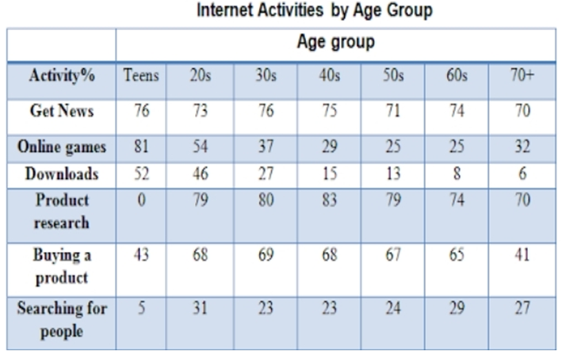

**OR**

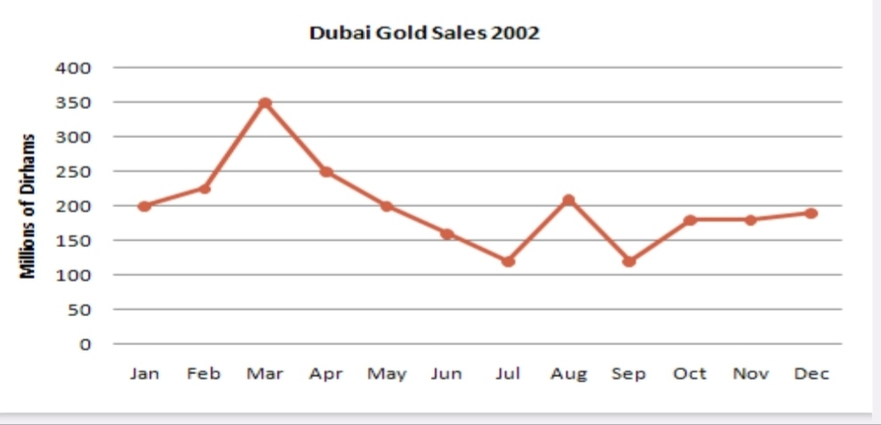B. The graph given shows estimated sales of gold in Dubai in 2002. Write an analytical paragraph describing the line graph in around 150 words.

**SECTION C – LITERATURE 40**

#### Attempt ANY ONE of two extracts given.

#### 6. Read the extracts and answer the questions that follow. 5

#### “Day after day she watched the bus, and gradually a tiny wish crept into her head and grew there: she wanted to ride on that bus, even if it was just once. This wish became stronger, until it was an overwhelming desire. Valli would stare wistfully at the people who got on and off the bus when it stood at the street corner. Their faces would kindle in her longings, dreams, and hopes. If one of her friends happened to ride the bus and tried to describe the sights of the town to her. Valli would be jealous to listen and would shout, in English: “Proud! Proud!”

* + 1. Valli would stare wistfully at the people as she

A Had been watching the bus for a long time. B Was inspired by the people travelling on the bus.

C. Had a strong desire to take a ride on the bus. D.Envied the people who could travel on the bus.

* + 1. Pick the option that shows the list of words that collocate with ‘overwhelming’ (e.g. overwhelming desire)

1.Response. 2. Lies. 3.Support. 4.majority 5.pets 6. places

Choose the correct option among the following:

a)1, 5 & 6. b) 1, 3 & 4. C) 2 & 5. D) 3, 5 & 6

* + 1. ‘Valli would be jealous to listen…’ This indicates Valli’s
  1. Longing to ride the bus. b) Nature as an envious person.

c) Denial to accept her situation. d) Inclination to trouble travellers.

iv. What does the line ‘gradually a tiny wish crept into her head and grew there’, mean? 2

#### OR

**B. Read the extracts and answer the questions that follow.**

**“Ramlal stood rooted to the ground, his head bowed low with the weight of grief and shame.**

**The flames of the sacred fire slowly died down. Everyone was gone. Ramlal turned to Bholi**

**and said, “But what about you, no one will ever marry you now. What shall we do with you?”**

**And Sulekha said in a voice that was calm and steady. “Don’t you worry, Pitaji! In your old age I will serve you and Mother and I will teach in the same school where I learnt so much. Isn’t that right, Ma’am?” The teacher had all along stood in a corner, watching the drama. “Yes, Bholi, of course,” she replied. And in her smiling eyes was the light of a deep satisfaction that an artist feels when contemplating the completion of her masterpiece.”**

i.Ramlal stood rooted to the ground because he

A Was moved by what he heard. B.Was influenced by Bholi’s words

C. Was in a state of shock. D.Was in an immovable position.

ii. Bholi had refused to get married as

A. Her father couldn’t afford the dowry that was demanded

B. The bridegroom had been greedy and was disrespectful

C. The bridegroom had insulted her father

D.Her father was getting her married to a man older to her

iii. Pick the sentence that brings out the meaning of ‘contemplating’ as used in the extract.

A.Contemplating sharing my belongings with someone is definitely tough.

B.She took some time to respond as she was contemplating what to say.

C.I was contemplating my reflection in the mirror and was speechless.

D.She was contemplating though the pages of the document that was with her.

iv. Why did the teacher stand in one corner watching the drama? 2

**7. Read the extracts and answer the questions that follow. 5**

**A. “**Ink trickled down to the bottom of the household,

And little mouse Blink strategically mouseholed.

But up jumped Custard, snorting like an engine,

Clashed his tail like irons in a dungeon,

With a clatter and a clank and a jangling squirm,

He went at the pirate like a robin at a worm”

i. Explain the central idea of the given lines in your own words. 2

ii What is the poet’s purpose of using the onomatopoeic words given in the extract?

a) It is to emphasize on the might and boldness of Custard.

b) It is to introduce the character Custard to the readers.

c) It is to impress upon the readers that Custard was ready.

d) It is to make Custard bold enough to face the situation.

iii Pick an option that best fits the usage of the word’ trickled’ as used in the extract.

a) The water trickled down the tap and filled the trough.

b) Students trickled into the classroom as the teacher entered.

c) Tears trickled down her cheeks as she heard the sad news.

d) His enthusiasm for the task slowly trickled away.

iv. ‘He went at the pirate like a robin at a worm. Why has this comparison been used here? Just like the

robin catches the worm,

a) Custard attacked the pirate after careful observation.

b) Custard attacked the pirate without delay.

c) Custard attacked the pirate valorously.

d) Custard attacked the pirate stealthily.

**(OR)**

B. “I heard an old religious man

But yesternight declare

That he had found a text to prove

That only God, my dear,

Could love you for yourself alone

And not your yellow hair.”

i) ‘yesternight’ is a word made of a combination of two words to form a new word.

Hence, it is a compound word.

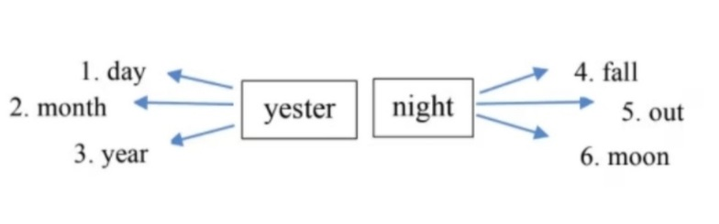 **Choose the words that DO NOT fit the description.**

* + 1. **3, 4. b. 2, 6. c. 3, 5. d. 1, 4**

ii). The above stanza strongly defies the idea of _.

a. internal qualities. b. external beauty. c. spiritual self. d. divinity

iii. Choose the option that displays the likely image of the man mentioned in the extract.

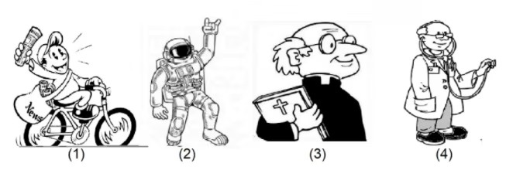a) option 1. b) option 2. c) option 3. d) option 4

iv ‘Love you for yourself alone” Explain. 2

#### 8. Answer ANY FOUR of the following in about 40-50 words each. 4x3=12

* + 1. How did Rajvir describe, the tea garden at Dhekiabari? (Tea from Assam)
    2. Why does the conductor call Valli ‘madam’? (Madam Rides the Bus)
    3. Why does the poetess use the metaphor of newly discharged patients? (The Trees)
    4. Describe the similarities that have been mentioned in the poem between the fog and a cat. (Fog)
    5. What do you learn about Natalya from the play, The Proposal?

#### 9. Answer ANY TWO of the following in about 40-50 words each. 2x3=6

* + 1. What kind of mother was Ramlal’s wife? (Bholi)
    2. **What were the factors which contributed in making Ebright a scientist?** (The Making of a Scientist)
    3. How did the Loisel replace the necklace? (The Necklace)

#### 10. Answer ANY ONE of the following in about 100-120 words. 6

* 1. How do Coorg‘s location, people and natural features add to the diversity of India? (Coorg)
  2. Ingenuity, originality and being inventive make one lovable, admirable and adorable. The author Gavin Maxwell and Mijbil, the otter, win our hearts for being original and inventive. Comment. (Mijbil The Otter)

#### 11. Answer ANY ONE of the following in about 100-120 words. 6

#### i) How did one old book of nursery rhymes save the Earth from a Martian invasion? (The Book That Saved The Earth)

ii) ‘―Oh! My poor Matilda! Mine was false. Confession saves you from a lot of trouble and the sense of Guilt.’ Justify the statement. (The Necklace).